**TOPICS: Allowed Time:** 90 Minutes

**Instructions: Total Marks:** 30

1. Gossips are not allowed.
2. Teacher assistants are for your help, so be nice with them. Respect them as they are teaching you. Raise your hands if you have some problem and need help from TA. Avoid calling them by raising your voice and disturbing the environment of Lab.
3. TA may deduct your marks for any kind of ill-discipline or misconduct from your side.
4. Evaluation will be considered final and you cannot debate for the marks. So, focus on performing the tasks when the time is given to you.
5. Paste the query as well as result table screenshot as a result of each task

**Task 01: _________________________ ___________ (07 Marks)**

1. Find Employees Who Were Hired Before the Manager of Their Department.

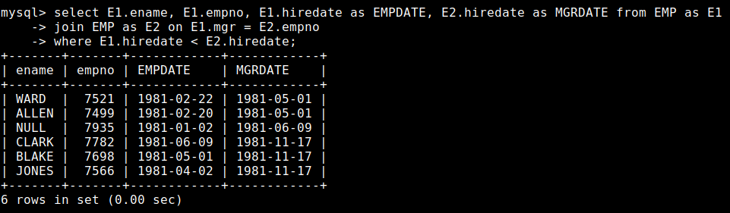

1. List all employees in department 20 who have a manager in department 10.

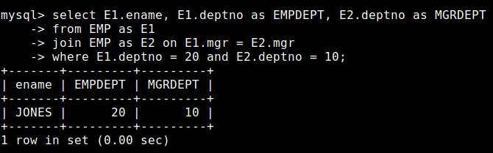

1. Find the name of the department with the highest number of employees.

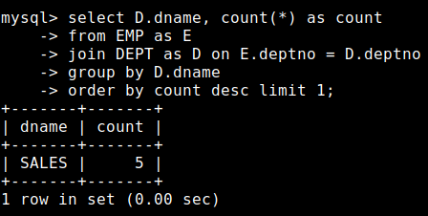

1. Find the job with the lowest average salary.

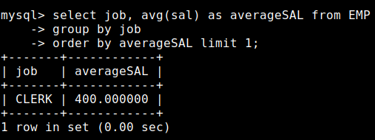

1. Display the department name of lowest paid employee without using join.

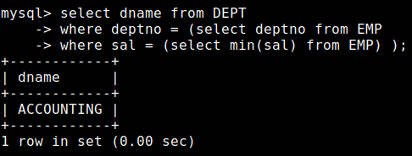

1. List the Names of Employees Working in the Same Location as Department 'SALES'

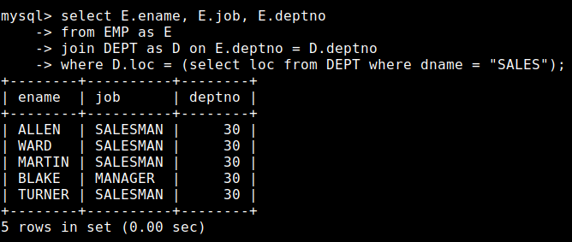

1. Find Departments Where All Employees Earn a Salary Greater Than 2000.

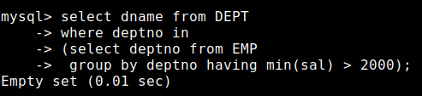

**Task 02: _________________________ ___________ (14 Marks)**

1. Find the employees who earn more than the average salary of their department.

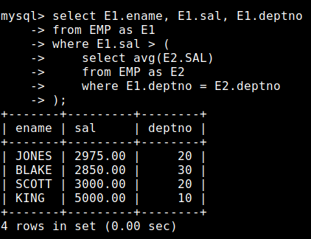

1. Find the employees who have the same manager as another employee.

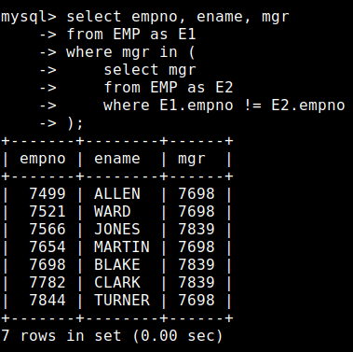

1. Find the department(s) that has at least one employee earning above the average salary in the department.

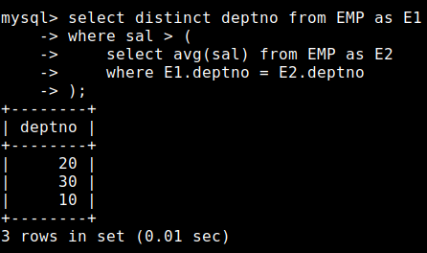

1. Find the number of Employees having same job as “Blake” and working in the Research Department.

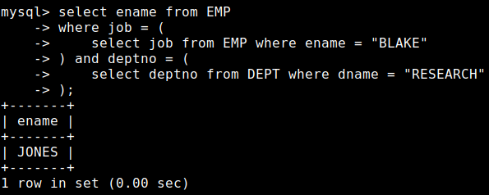

1. Find the department with the highest number of employees earning above the highest salary in grade**.**

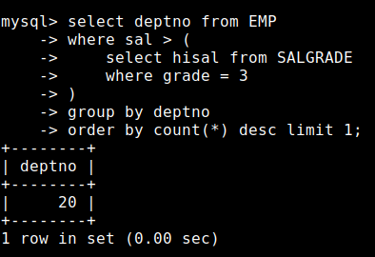

1. Find employees with salaries that match the highest and lowest salaries for each grade.

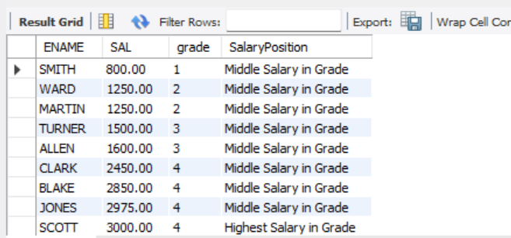

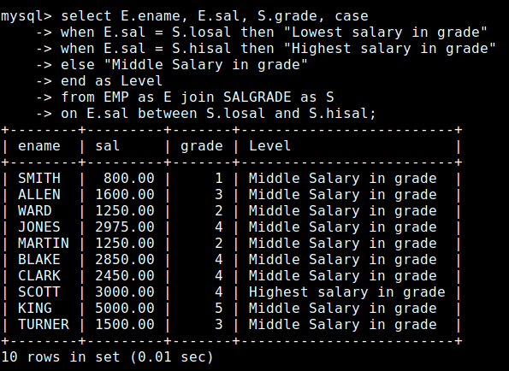

1. Find the employee with the THIRD lowest salary.

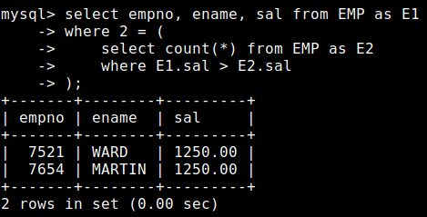

**Task 03: _________________________ ___________ (09 Marks)**

1. **Find the Department with the Most Employees Earning Over 2000.**

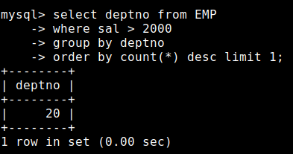

1. List the Departments Where the Average Salary of Employees is Greater Than the Salary of the Highest Paid Employee in the Department Who is Not the Manager of Any Employee.

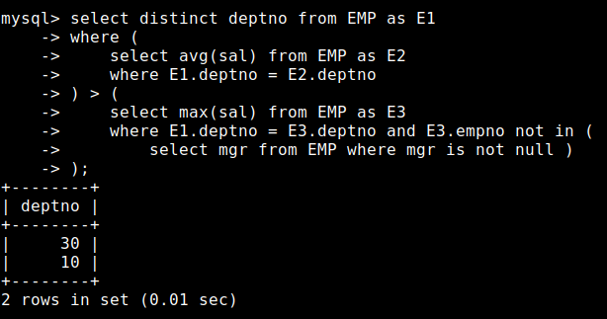

1. **Find Employees Who Have a Manager in a Different Department.**

